

American International University-Bangladesh (AIUB)  
Department of Computer Science  
Faculty of Science &Technology (FST)  
Summer 22 23

Section: D  
Software Quality Assurance and Testing

**E-COMMERCE APP**

A Report submitted By

|  |  |  |
| --- | --- | --- |
| SN | Student Name | Student ID |
| 1 | Dipon Basak | 19-39463-1 |
| 2 | Md Redoy sheikh | 19-40101-1 |
| 3 | Mahdi Md Muhaimenul Islam | 19-39845-1 |
| 4 | Farhan Imran | 18-39141-3 |
| 5 | Md. Mostak Jakaria Sohan | 18-38543-2 |

Under the supervision of

FARZANA BENTE ALAM

Lecturer, CS

Software Test Plan

for

E-Commerce App

Version 1.0 approved

Prepared by   
Dipon Basak  
Md Redoy sheikh  
Mahdi Md Muhaimenul Islam  
Farhan Imran  
Md. Mostak Jakaria Sohan

American International University-Bangladesh(AIUB)

22-08-2022

Table of Contents

Revision History 3

1. TEST PLAN IDENTIFIER: RS-MTP01.3 3

2. REFERENCES 3

3. INTRODUCTION 3

Background to the Problem 3

Solution to the Problem 4

4. REQUEIREMNT SPECIFICATION 4

4.1 System Features 4

4.2 System Quality Attributes 4

4.3 System Interface 5

4.4 Project Requirements 5

5. FEATURES NOT TO BE TESTED 5

6. TESTING APPROACH 5

6.1 Testing Levels 5

6.2 Test Tools 6

6.3 Meetings 6

7. TEST CASES/TEST ITEMS 6

8. ITEM PASS/FAIL CRITERIA 7

9. TEST DELIVERABLES 7

10. STAFFING AND TRAINING NEEDS 8

11. RESPONSIBILITIES 8

12. TESTING SCHEDULE 8

13. PLANNING RISKS AND CONTINGENCIES 9

14. APROVALS 9

# Revision History

|  |  |  |  |
| --- | --- | --- | --- |
| Revision | Date | Updated by | Update Comments |
| 0.1 | 2022.08.14 |  | First Draft |
| 0.2 | 2022.08.15 |  | Second Draft |
| 0.3 | 2022.08.16 |  | Third Draft |
| 0.4 | 2022.08.17 |  | Fourth Draft |
| 0.5 | 2022.08.21 |  | Fifth Draft |
| 0.6 | 2022.08.21 |  | Sixth Draft |

# TEST PLAN IDENTIFIER: RS-MTP01.3

# REFERENCES

* Any reference documents with the test plan. For example: Software Requirement Specification (SRS) Document

# INTRODUCTION

Any activity involving the buying or sale of items through online services is referred to as e-commerce. In this pandemic state, we rely heavily on online retailers. Because several online stores sell a variety of goods at various price points, customers are frequently perplexed when making purchases. The e-compare app provides this option to help clients compare products and pick the best one from a selection of comparable options. Before making a purchase, customers may quickly evaluate product features and costs.

## 3.1 Background to the Problem

Online shopping is increasingly common. People occasionally find it difficult to choose a decent product, and vice versa. Online shoppers are unable to evaluate the product's quality and are unaware of the precise supplier. Because of this, people are unable to purchase the product in response to demand and there is a significant chance that they will be duped.

## 3.2 Solution to the Problem

This E-Commerce App (ECA) compares E-commerce products to increase the efficiency of online buying. People can find the finest products at the best rates from the best sellers by utilizing this software's features and its comparison tool, which contain several unique characteristics. This software comprises some of the largest e-commerce websites, their news, and a sizable database of seller information and reviews, which are the most important factors in product purchases. Online purchasing has gained popularity. On occasion, choosing a quality product might be challenging, and on other occasions, it can be hard to locate. However, folks may overcome this issue with the aid of this program and will be able to have a much better experience.

# REQUEIREMNT SPECIFICATION

## System Features

1. **Create Account**

Functional Requirements

1. Users can register for the software using their phone number and email address.
2. Next, users' information must be coerced to be registered in the system, allowing for the establishment of each user's identity and the execution of the necessary group activity. A person must provide all of their information accurately and completely in order for others to be able to recognize them and think that the person they are interacting with is actually them.
3. Without registering, a user can view a limited number of options and pages on the home page and read about the features, but he is not permitted to use them. He will need to register in order to use.

**Priority Level:** High

**Precondition:** User must have valid email id and phone number

1. **System Login**

Functional Requirements

1. The software must enable user login using the provided username and password.
2. The system will create a random verification code to try to log you in again if you've entered the erroneous username or password more than three times.
3. The system will disable user account login for one hour if the maximum allowed number of login attempts (5 times) is reached.

**Priority Level:** High

**Precondition:** User must have valid user id and password.

1. **Forgot password**

Functional Requirements

1. There will be a forgotten password module that allows users to quickly reset their password. Therefore, customers only need to enter their phone number or email address.
2. They will receive a confirmation email or a message to their phone number with the option to reset their password. This module can be used to solve the password-forgetting problem in a matter of seconds.

**Priority Level:** High

**Precondition:** user have valid email id or phone number

1. **Select Website**

Functional Requirements

* 1. The software must enable users to choose additional websites from the primary website. They have the option of choosing one website, several websites, or all other websites.
  2. Users must select a website using the checkbox option. The users won't take any further action unless they choose at least one website.

**Priority Level:** High **Precondition:** User must have valid user id and password.

1. **Search (With Comparing)**

Functional Requirements

1. Users will be able to do searches for the products they want using the software. Their desired product will be immediately compared to all other websites, giving them a positive outcome.
2. The software will display a notification that the searched products are not available.

**Priority Level:** High **Precondition:** user has to log in first as a customer.

1. **Updating Data**

Functional Requirements

1. The program will enable the administrator and agent to update any data and product specifics.

**Priority Level:** High **Precondition:** user has to log in as an admin

1. **Deleting Data**

Functional Requirements

1. Admin will be able to delete the desired information using the software.
2. The software will display a notification that the data the user wants to delete does not exist if it does, and it will ask the user if they are sure they want to delete it before deleting it by displaying a yes/no notification.

**Priority Level:** High **Precondition:** user has to log in as an admin

1. **Online Payment**

Functional Requirements

1. The software must enable customers to pay online after choosing their chosen item. The software allows users to use an online payment system to purchase the products they wish.
2. Any online payment method, including credit card, bkash, and nagad, is available to users.

**Priority Level:** High **Precondition:** user has to log in first as a customer.

1. **Coupons**

Functional Requirements

1. Users must be able to use coupons with the software. when customers use ECA to make large purchases. Coupons will be put to their ECA account so they can use them to purchase goods the next time.
2. Users may purchase their desired products if the amount of coupons available is less than the price of the chosen goods.

**Priority Level:** Medium **Precondition:** user has to log in first as a customer.

1. **Helpline**

Functional Requirements

1. Users will have access to a helpline from 9:00 am to 9:00 pm. Users can contact us via live chat if they run into any problems or require information regarding our products, accounts, or any other kind of assistance.

**Priority Level:** Medium **Precondition:** user has to log in first as a customer

1. **News Feed**

Functional Requirements

1. Users of the software will receive news about new products that will be released in the future and new deals from online retailers.

**Priority Level:** Low **Precondition:** user has to log in first as a customer

## System Quality Attributes

The program will be accessible around-the-clock. If any unfavorable situation arises, it will be simple to perform any kind of action from anywhere at any time because the software would be online-based.

**Performance:** The software will load in no more than 10 seconds. This means that if a trained user issues a command for an operation, the result will be displayed in no more than 10 seconds.

**Efficiency:** At the anticipated peak load conditions, the program will only consume 25% of the processor and RAM that are available to it. In order for the user to still receive a prompt answer even when there are many users.

**Integrity:** The only people with the authority to alter, add to, edit, or remove any type of data are admins. Once more, if a user tries to conceal their location or identity, the software will stop all of their operations.

**Reliability:** The software only fails five out of a thousand experimental runs.

**Robustness:** Because sometimes users forget to log out of the system, the software will automatically log the user out after 10 minutes to prevent being hacked. Furthermore, the software saves data every ten seconds while the user is inputting something so that, in the event of an inconvenience, the user can resume data entry where he left off. Flexibility: Since the program is a major undertaking, it is adaptable enough to support the addition of additional features in the future as needed.

**Usability:** A skilled user should be able to submit a complete request for creating, updating, deleting, and searching an order or request in less than two minutes.

**Maintainability:** A user can simply change any information if it is entered incorrectly, but only after going through security checks.

**Reusability:** The system structure can be recycled to create a different management system for a different school, college, or university.

**Testability:** Each module has a 20-cycle maximum cyclamate complexity limit. As a result, if the product is frequently modified, it will also be frequently tested for regression to see if the changes have affected any feature that has already been implemented.

## System Interface

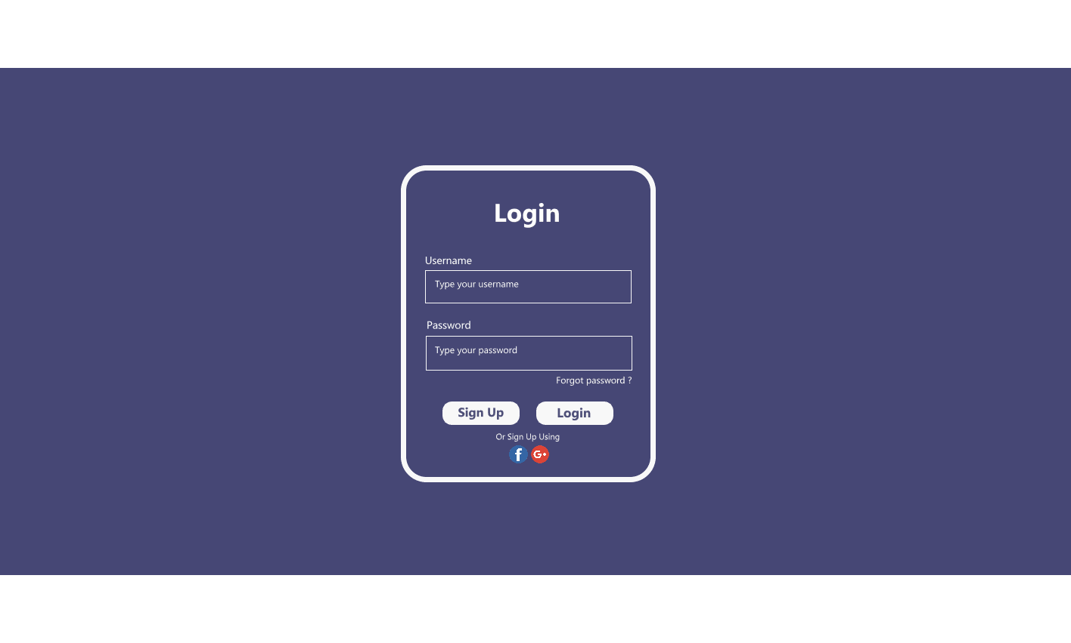

**Fig 4.3.1: Login Form**

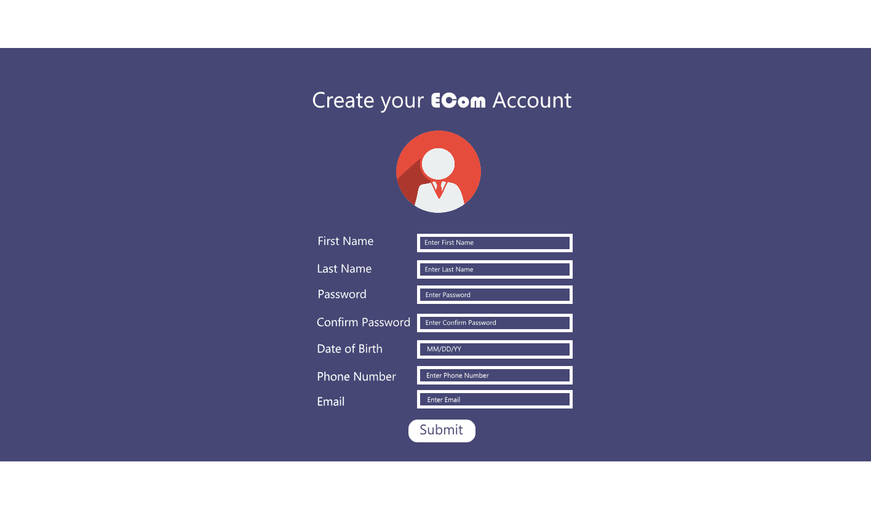

**Fig 4.3.2: Create Account Form**

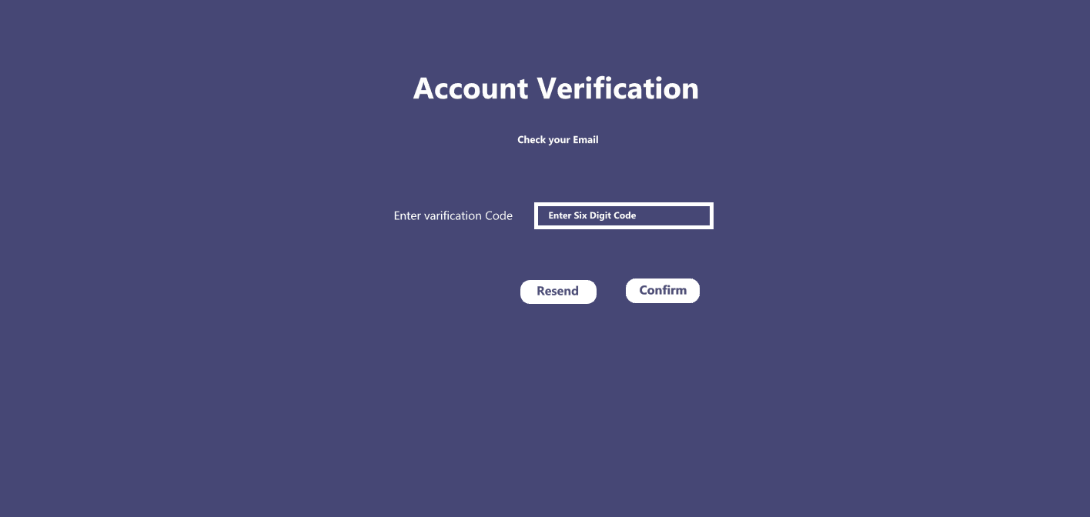

**Fig 4.3.3: Account Verification Form**

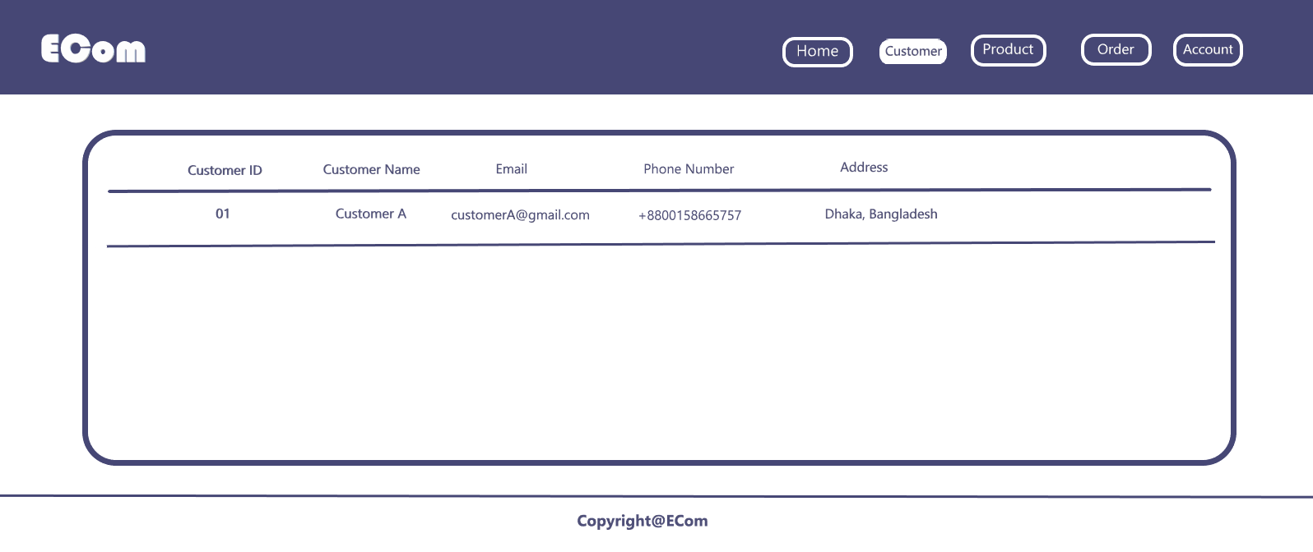

**Fig 4.3.4: Admin Customer View Page**

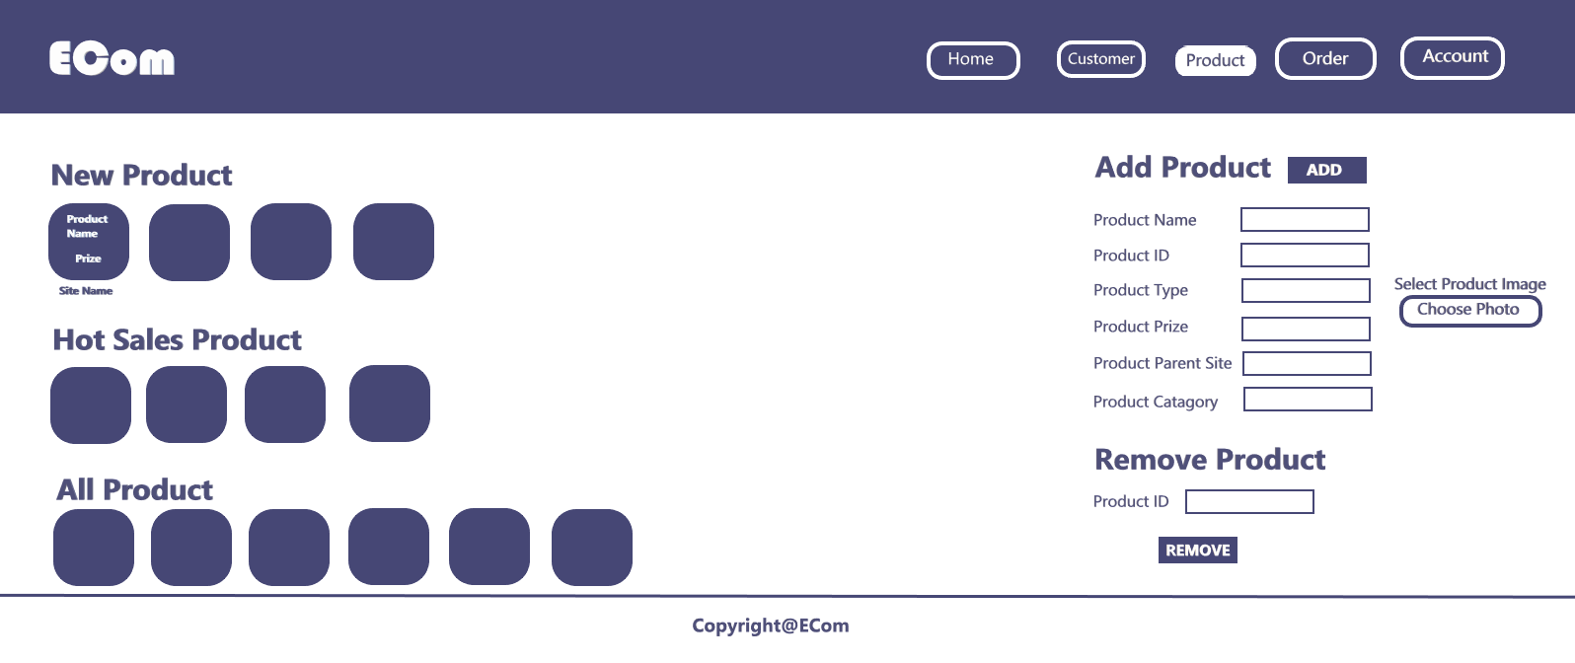

**Fig 4.3.5: Admin Product Control View**

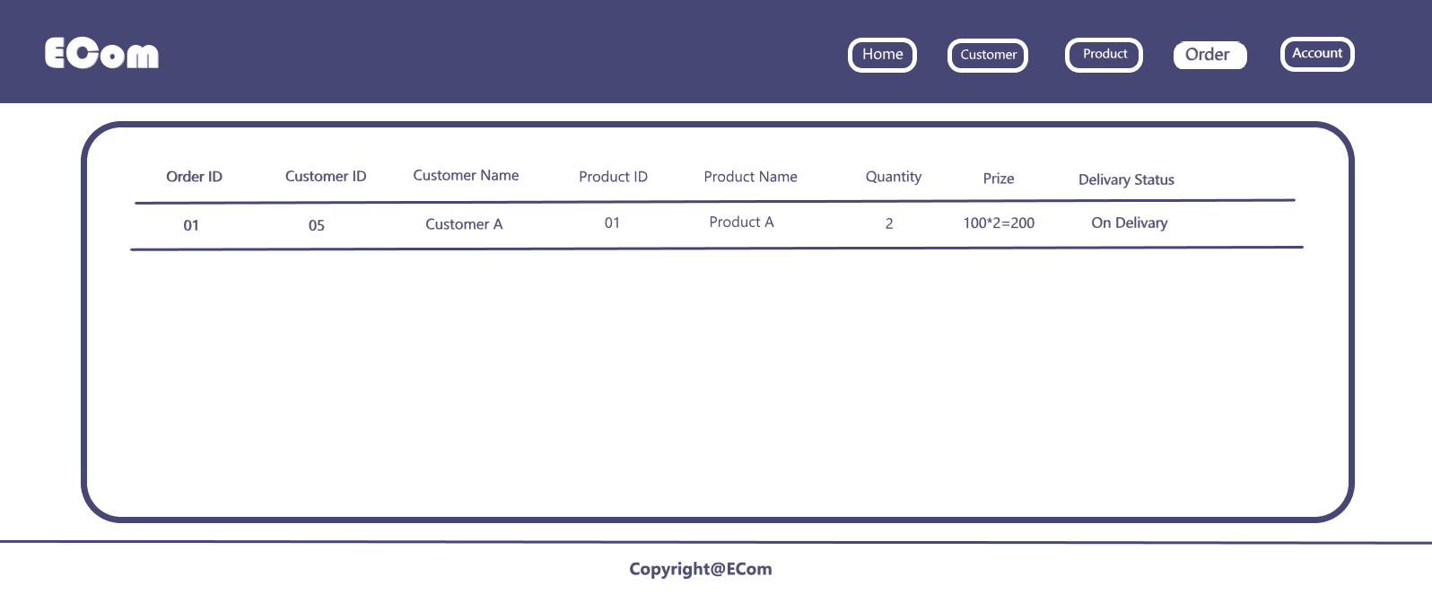

**Fig 4.3.6: Admin Order Control View**

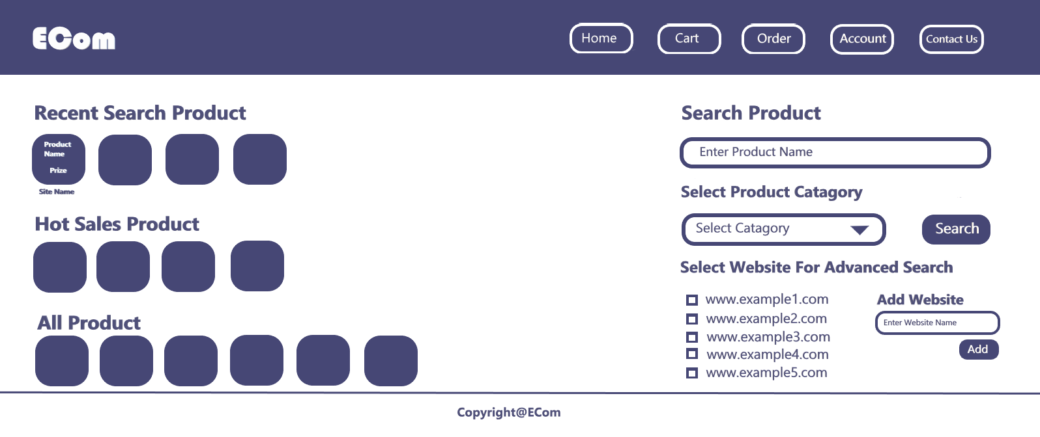

**Fig 4.3.7: Customer Landing Page**

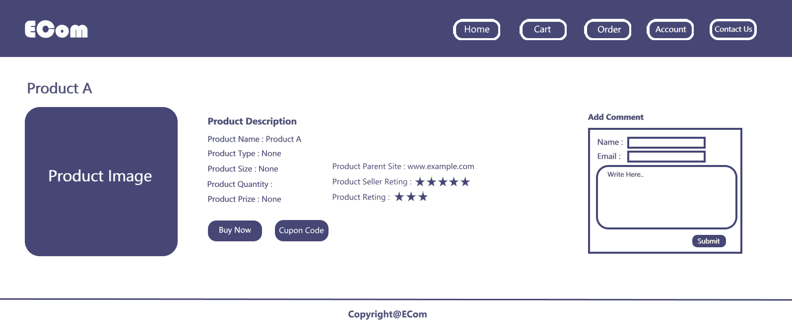

**Fig 4.3.8: Customer Product View Page**

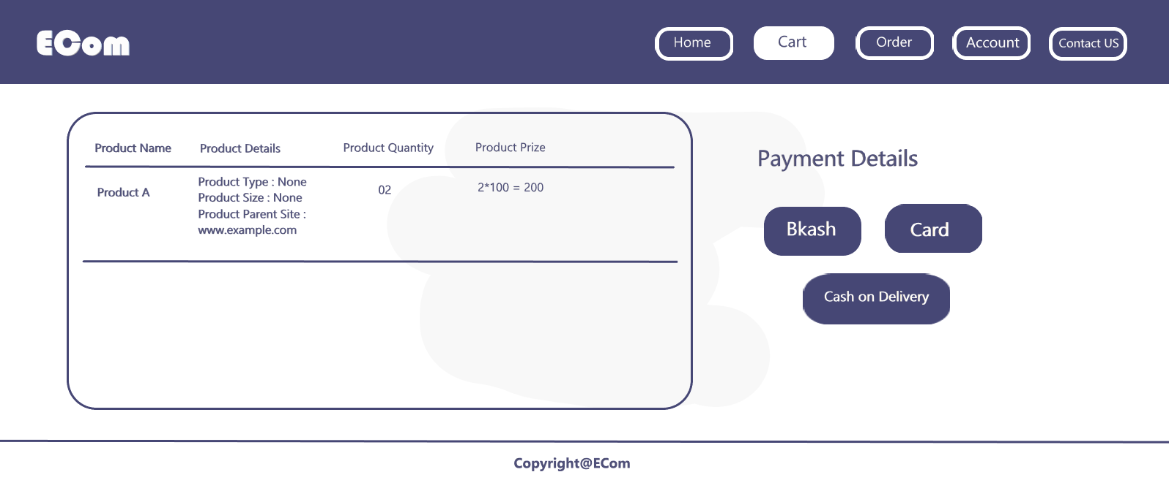

**Fig 4.3.9: Customer Product Cart and Payment View**

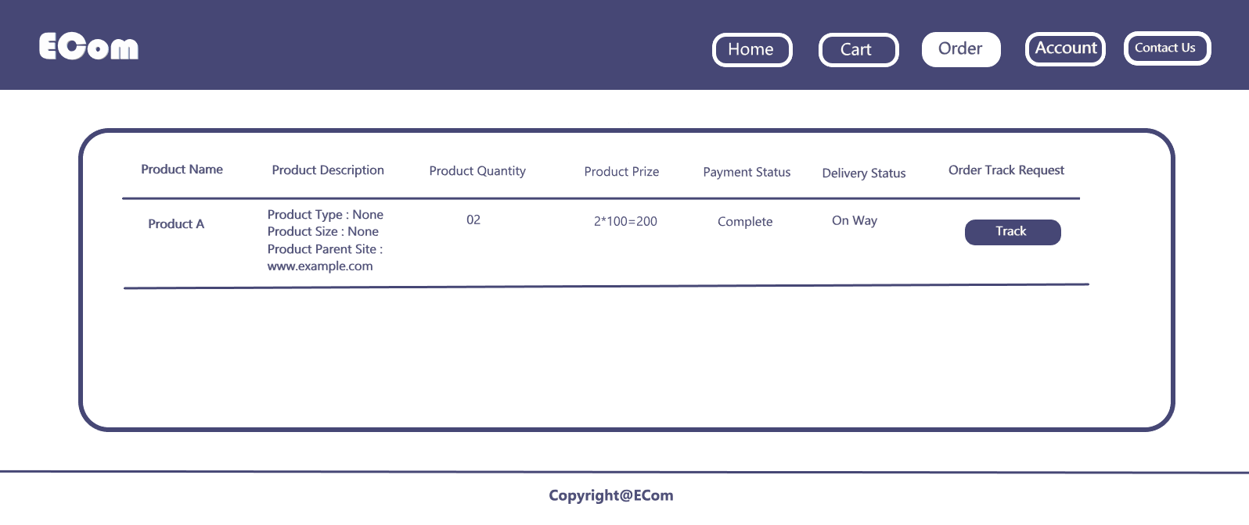

**Fig 4.3.10: Customer Product Order View**

## Project Requirements

* **Budget**

The total budget of this project is 6, 50,500 BDT including all costs and recourses

* **Resources**

Big Commerce (Website Builder)

Go daddy (Domain provider)

UI/UX design Tool - Paint3D

Data Base- Mongo DB

Front End-HTML-5

Back End -JavaScript, React JS, and Node JS

* **Time**

**15** weeks is the estimated time to complete the whole project.

# FEATURES NOT TO BE TESTED

In this category we are not going to tested anything which has no functionality like

1. System Database
2. Contact us module, user can directly call by use their mobile phone there is no functionality. But there will be live support options like messaging that will be tested properly.

# TESTING APPROACH

## Testing Levels

1. First, we must decide which requirements will be tested; all test cases must be documented.
2. For each module, determine the test data and test cases needed to ensure a successful test operation.
3. The expected outcome for each result has been identified.
4. Every module and function is put through both positive and negative tests by test engineers for every test approach.
5. The developer will be notified to resolve the bug when it has been fixed, and then we will do Sanity testing to determine whether or not the bug has been fixed. At first, smoke testing will be conducted for the most fundamental and crucial component of this system using the documented test case.
6. Then, test engineers begin the unit/component testing where they examine if each function of each module is operating correctly or not by testing each component or function separately.
7. When unit testing has been completed successfully, test engineers move on to integration testing, which involves combining two or more modules, testing them together, and ensuring that both modules are functioning effectively.
8. If a requirement changes during development and the customer requests a change in one of the modules, the developers complete the implementation work, send it to the test engineers, and begin full regression testing on the changed module as well as the rest of the modules to ensure that the change has no impact on the rest of the modules.
9. The next testing strategy will be system testing, also known as alpha-beta testing, where some of our staff members and customers will test the program and abuse it as much as possible. They test in the manner of actual users, and if any flaws are discovered they notify the developers and test engineers.
10. Ad hoc testing is the second-to-last test in our testing methodology, in which our test engineers test the system by breaking every system requirement. In this test, test engineers test the system haphazardly and without first understanding the requirement. Engineers are put to the test using this testing method.
11. The final step before handing over the customer to their software is acceptance testing. Customers utilize this system for a brief period of time to conduct end-to-end testing to determine whether the software can manage real-time company operations and whether it is totally compatible with their expectations and hiring needs.
12. Each technique's results should be documented, and if test engineers discover any errors or bugs while executing any technique, a bug report form should be generated. This form should contain information about the test case, the issue that was encountered, its likely origin, and the chain of events that led to the issue. This information will aid the developers in resolving the bug. Because repairing a bug took longer.
13. Following the completion of each testing approach, the test data, test cases, and test results are all documented and delivered via System Test Report.
14. It is required to submit test documentation and reports. Any requirements that need to be examined, changed, or updated must be taken care of right away.

## Test Tools

The only automated test tools to be used in this project is TestProject. TestProject is the world's first free test automation platform for web, mobile and API testing, designed for all testers and developers.

## Meetings

TestProject is the only automated testing software that may be used for this project. The first free test automation platform for online, mobile, and API testing, TestProject was created for all developers and testers.

# TEST CASES/TEST ITEMS

|  |  |  |  |  |  |
| --- | --- | --- | --- | --- | --- |
| Project Name: E-Commerce App | | | Test Designed by:  MD REDOY SHEIKH | | |
| Test Case ID: FR_1 | | | Test Designed date:  15-10-2022 | | |
| Test Priority (Low, Medium, High): High | | | Test Executed by: | | |
| Module Name: Registration Session | | | Test Execution date:  DD-MM-YYYY | | |
| Test Title: Verify the users with valid information | | | | | |
| Description: Test the registration feature for mobile applications. | | | | | |
| Precondition (If any): User must have a working phone number and email address. | | | | | |
| Test Steps | Test Data | Expected Results | | Actual  Results | Status  (Pass/Fail) |
| 1. Open the Web application. 2. Click on Sign up. 3. Enter First Name. 4. Enter Last Name. 5. Enter Phone Number. 6. Enter Email Id. 7. Enter password. 8. Click Submit. | First Name:  MD Redoy  Last Name:  Sheikh  Phone Number:  01735300454  Email Id:  mdhidoyhassan@gmail.com  Password: 12345 | User should register successfully | |  |  |
| Post Condition: Successful login to the account and successful documentation of user information in the database. | | | | | |

|  |  |  |  |  |  |
| --- | --- | --- | --- | --- | --- |
| Project Name: E-Compare App | | | Test Designed by:  Name | | |
| Test Case ID: FR_2 | | | Test Designed date:  DD-MM-YYYY | | |
| Test Priority (Low, Medium, High): Medium. | | | Test Executed by: | | |
| Module Name: Forget Password Session | | | Test Execution date:  DD-MM-YYYY | | |
| Test Title: Verify user new password. | | | | | |
| Description: Test mobile application forget password feature. | | | | | |
| Precondition (If any): User must have valid email id or phone number. | | | | | |
| Test Steps | Test Data | Expected Results | | Actual  Results | Status  (Pass/Fail) |
| 1. Open the Web application. 2. Click on Forget Password. 3. Enter Email address or Phone number. 4. Enter Confirmation Code. 5. Enter New Password. 6. Click Submit. | Phone Number:  01682860185  Code:  145678  New Password:  236587 | User should login to the  application | |  |  |
| Post Condition: User is successfully login to account. | | | | | |

|  |  |  |  |  |  |
| --- | --- | --- | --- | --- | --- |
| Project Name: E-Commerce App | | | Test Designed by:  Name | | |
| Test Case ID: FR_3 | | | Test Designed date:  DD-MM-YYYY | | |
| Test Priority (Low, Medium, High): High. | | | Test Executed by: | | |
| Module Name: Searching Data Session | | | Test Execution date:  DD-MM-YYYY | | |
| Test Title: Verify the Searching data | | | | | |
| Description: Test mobile application searching data feature. | | | | | |
| Precondition (If any): User must have to login | | | | | |
| Test Steps | Test Data | Expected Results | | Actual  Results | Status  (Pass/Fail) |
| 1. Open the Web application. 2. Login into the application. 3. Enter Desire information. 4. Click on Search. | Search:  Any desire item | System should provide all the information about that specific item after doing comparison with other sites. | |  |  |
| Post Condition: User has been provided by his/her desire item | | | | | |

|  |  |  |  |  |  |
| --- | --- | --- | --- | --- | --- |
| Project Name:  E-Commerce App | | | Test Designed by:  BASAK, DIPON | | |
| Test Case ID: NFR_4 | | | Test Designed date:  DD-MM-YYYY | | |
| Test Priority (Low, Medium, High): High | | | Test Executed by: QA testers or real time users | | |
| Module Name: Usability Testing | | | Test Execution date:  DD-MM-YYYY | | |
| Test Title: Examines the system's suitability for human use. | | | | | |
| Description: Test the application is ready for use or not | | | | | |
| Test Steps | Test Tool | Expected Results | | Actual  Results | Status  (Pass/Fail) |
| 1. Planning the details of the usability testing.    2. Designing the task.    3. Conducting usability test.  4. Running the session  5. Analyzing the insights. | 1.UserZoom(Enhance digital experience with brands)  2. Task Based (Simulate  the real experience of users)   3. User Testing(Written  Feedback)  4. Feedback /Survey (Concept Feedback) | The user experience with the application is positive and simple.  The user understands the application easily. | |  |  |

|  |  |  |  |  |  |
| --- | --- | --- | --- | --- | --- |
| Project Name: E-Commerce App | | | Test Designed by:  Name | | |
| Test Case ID: NFR_5 | | | Test Designed date:  DD-MM-YYYY | | |
| Test Priority (Low, Medium, High): Medium | | | Test Executed by: | | |
| Module Name: Security Testing | | | Test Execution date: | | |
| Test Title: Test the security of the application | | | | | |
| Description: Security Testingincludes the testing of authentication, authorization, integrity, and availability. | | | | | |
| Test Steps | Test Tool | Expected Results | | Actual  Results | Status  (Pass/Fail) |
| 1. **Test the Accessibility.** 2. **Test the Protection Level of Data.** 3. **Test for Malicious Script.** 4. **Test the Access Points** 5. **Test the Session Management.** | Net sparker (It is one of the best and accurate tools used in the market for web application security).Sonar Qube (It is an open-source security testing tool)ZED Attack Proxy (ZAP) (It is an open-source security testing tool that can run on multiple platforms). | The application has the capability of secure from any hardware and software failure. | |  |  |

# ITEM PASS/FAIL CRITERIA

The test is generally deemed successful when the system complies with the requirement. If the test results are less than 90%, it can be said that the test failed. Otherwise, it can be said that the exam passed. It is possible, however, for conditions to occur during testing, such as when an event cannot be repeated or when environmental problems are a worry, etc. The testers can be unsure of what qualifies as a pass or failure. In these circumstances, it can be regarded as a failure.

# TEST DELIVERABLES

Test Deliverables are "things" produced by those involved in the process and provided to the stakeholders. They are called artifacts. Prior to testing, during testing, and after testing, various deliverables are provided. Below is the list of test deliverables

* Test plan document.
* Test cases.
* Test design specification.
* Tools and their outputs.
* Simulators.
* Static and dynamic generators.
* Error logs and execution logs.
* Problem reports and corrective actions.

# STAFFING AND TRAINING NEEDS

## STAFF NEEDS

The efficiency of the development process and the quality of the finished product are directly correlated with developer skills. How to appropriately staff the project is one of the most crucial considerations a software project manager must make. Depending on the project and organizational requirements, the manager may have to select a team from a bigger pool of potential developers. There are many options to consider, several developer-to-activity pairings to consider.

## TRAINNING NEEDS

The Test Manager and Project Manager must work with administrative staff to receive training on the inner workings of a course allocation flow, learn about available courses, and understand the requirements for prerequisite courses.

# RESPONSIBILITIES

|  |  |
| --- | --- |
|  | **Responsible For** |
| Senior  Project Manager | * Approving the test plan. * In charge scheduling, budgeting, execution and delivery of software * Responsible to spot if there will be any change in project, and inform early to project leader and address him. * Final acceptance of the component. |
| Project Leader and Project Architecture | * Working with hole team especially testing and developing team to address any concern * Lead and provide support the whole team and design the system interface. * Providing the test environment. * Witnessing the performance of the tests and monitor the interface design build properly or not. * Responsible for inform senior project manager for any critical issue. * Receiving and checking the test results. |
| Test Analyst | * Designing any custom test procedures. * Preparing the test environment. * Executing the tests according to the test plan. |
| Testing  Team Manager | * Managing the overall testing process and the test personnel. * Finalizing the test plan. * Providing the test tools. * Checking the test results. |
| Developer  Team Manager | * Providing the test items with their associated transmittal reports. * Ensuring that the test personnel are able to properly connect the equipment. * Witnessing the performance of the tests. * Checking the test results. * Resolving any areas of non-conformance identified. |

# TESTING SCHEDULE

For the project, time is crucial. The work has a due date, so we must create a schedule to meet it.

In the project plan schedule, the precise hours and dates for each action are specified. The project manager, in collaboration with the heads of the development and test teams, will be in charge of coordinating the employees needed for each assignment, as well as the test team, development team, management, and customer.

|  |  |  |
| --- | --- | --- |
| **Work No** | **Phase** | **Schedule** |
| **1** | Document | September 26 to October 1 |
| **2** | Design | October 1 to October 7 |
| **3** | Test plan | October 8 to October 13 |
| **4** | Unit Testing | October 14 to October 21 |
| **5** | Integration Testation | November 14 to November 21 |
| **6** | System Testation | November 22 to November 28 |
| **7** | Acceptance testation | November 28 to December 3 |
| **8** | Project Completion | December 3 to December 9 |

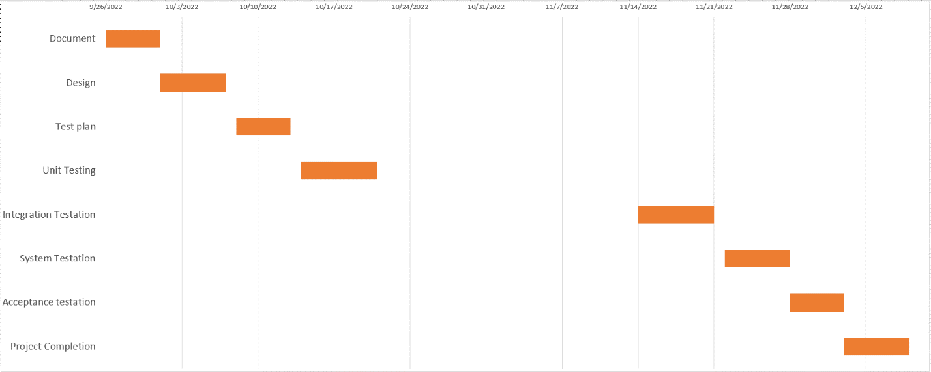**Gantt Chart**

# PLANNING RISKS AND CONTINGENCIES

Since there is a lack of sales employees, the project may be delayed because there are open vacancies. When a day passes without the appearance of a new worm or other exploitable weakness, it always comes as a welcome surprise. This is due to the fact that we are in shark-infested seas and that it is necessary to reassess our strategic and tactical Web commerce plans. In order to acquire executive approval for risk management and contingency planning, it is important to acknowledge that e-commerce is a target (and a profitable one at that).

|  |  |  |  |  |
| --- | --- | --- | --- | --- |
| **Risk** | **Probability** | **Risk Type** | **Owner** | **Contingencies Mitigation**  **Approach** |
| Unable to find enough skilled workers as soon as the components are available for testing. | 30% | Personnel Schedule | Test Manager | Component resources will be distributed among the available resources. The schedule needs to be changed accordingly. |
| not being able to obtain certain hardware and software requirements for system testing and integration | 25% | Equipment | Program Manager Test Manager Development manager | Utilize the hardware you've already bought. So that testing can be done for multiple teams on the same day using the limited hardware, divide test execution into 24/7 support. This necessitates continual support for development. |
| Deliveries of components are delayed. | 25% | Schedule | Development Manager | Until the component is provided, integration testing with those components must be postponed. The overall integration test approach can be changed to incorporate sandwich integration, top-down integration, and the necessary degree of bottom-up integration. Schedule It must be changed appropriately. |

# APROVALS

|  |  |  |
| --- | --- | --- |
| Senior Project Manager | INDROJIT DHE SHAON |  |
| Project Leader  and Project Architecture | MEHENAZ ALAM CHOWDHURY TONNY |  |
| Test Analyst | SAJIDUL HASAN |  |
| Testing  Team Manager | AYON ROY |  |
| Development Team Manager | SAJIDUL HASAN |  |